# H2 – Serializing data using WEKA

**Introduction**

Weka is an open source framework created by the University of Waikato that is used for Data Mining and Data Analysis.

**Development**

First of all, the Training.csv file obtained from Homework 1 Had to be converted to a Weka File (.artff). Then Data was analyzed involving the different twelve features of the Data Set.

*Score_tag*

In score_tag, it is appreciated that P has the higher score among all the possible options, but, the gap between P and N & NEU is not as big compared with NONE, P+ and N+, which have extremely low values.

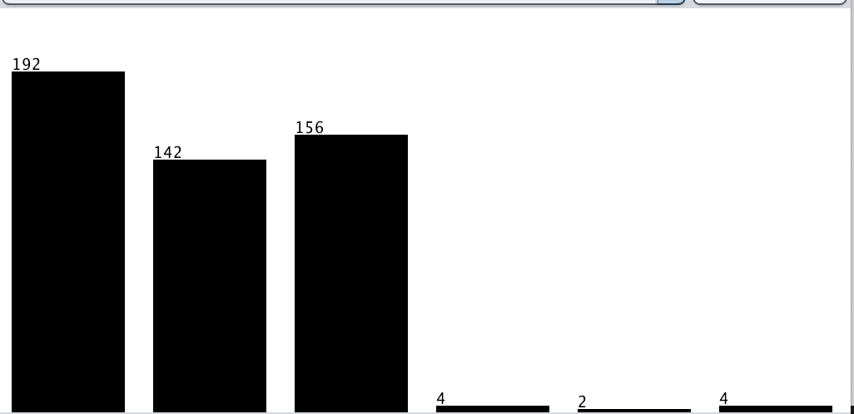

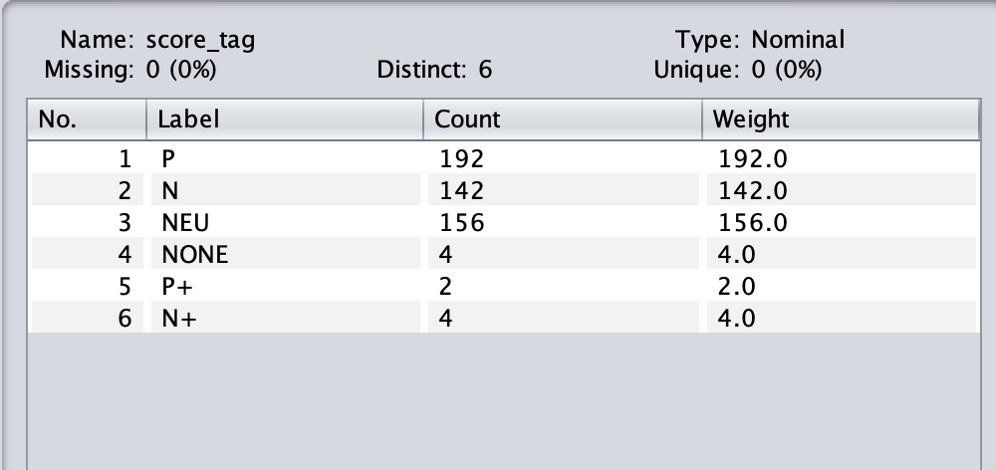

*Agreement*

According to the following histogram, it is appreciated that disagreement outnumbers agreement, therefore it can be concluded that the majority of the fake news disagree.

**

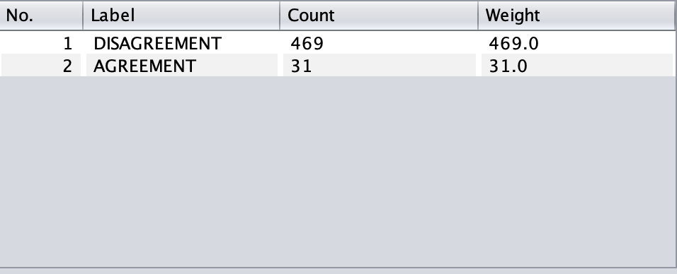

*Subjectivity*

In this case, subjective is greater than objective, hence, it can be concluded that fake news is more likely to be subjective.



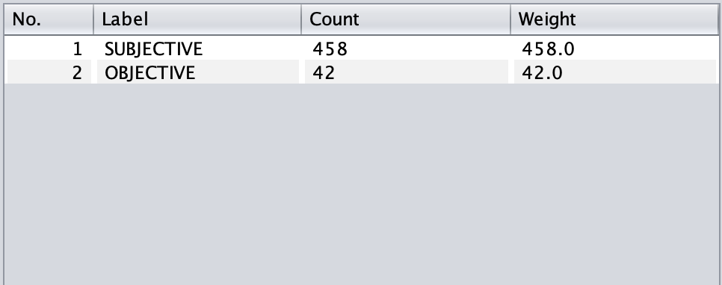

*Confidence*

Confidence looks to be neutral in this chart, but in fact it is a little bit closer to the right, so it is concluded that fake news tend to look confident.

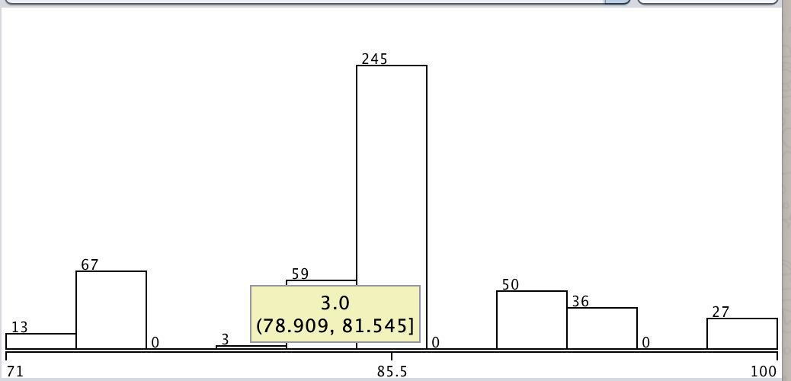

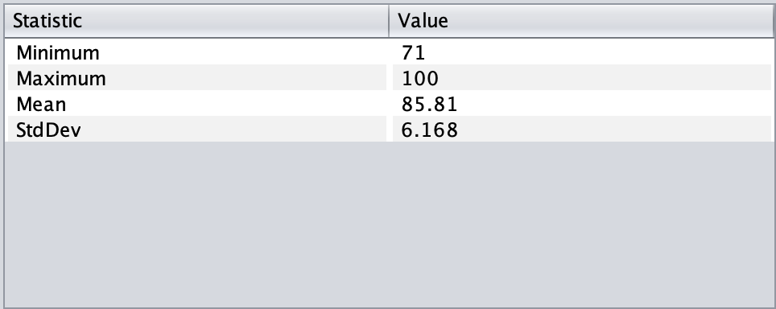

*Irony*

The NONIRONIC column is almost 5x bigger than the IRONIC column, so it is concluded that fake news are not usually ironic.

**

*Happy*

In this plot, happy is plotted against angry. It can be observed that there exists a certain negative correlation between both features.

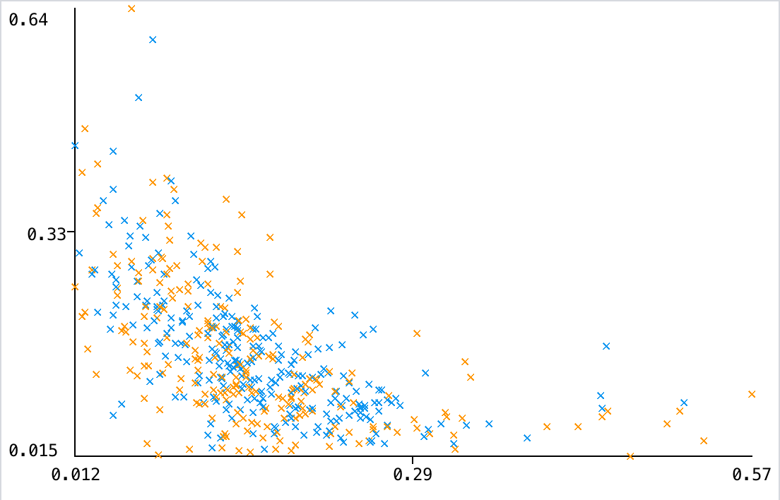

*Angry*

In this plot, it can be observed that the plot has left skewness, indicating that in general, most of the fake new do not present angriness.

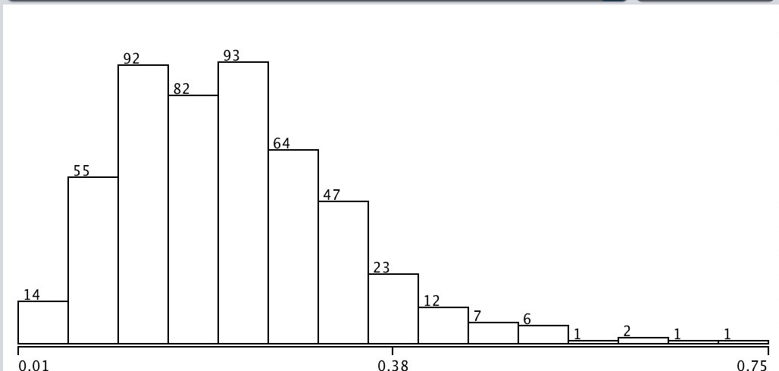

*Bored*

In this plot, it can be observed that the plot has a lot of skewness to the left, so there are not many bored emotions in fake news.

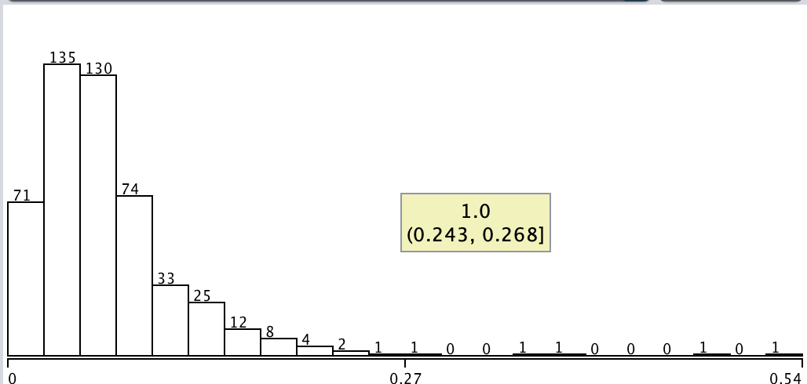

*Fear*

In this plot, it can be observed that there is no correlation between fear and angry.

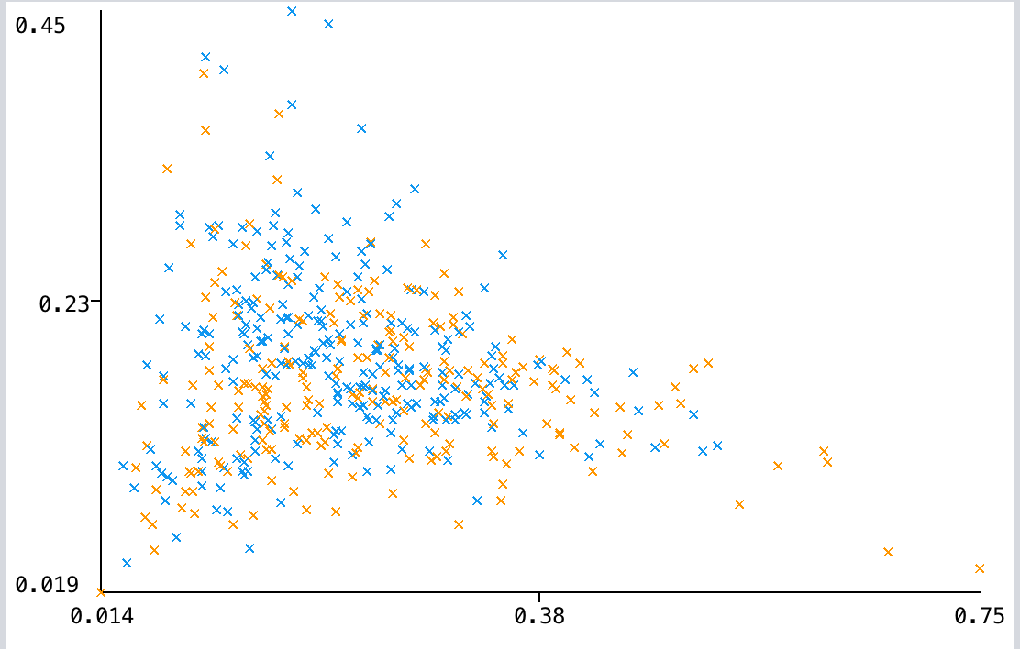

*Sad*

In this plot, it can be observed that it exists a certain negative correlation between sad and happy in fake news.

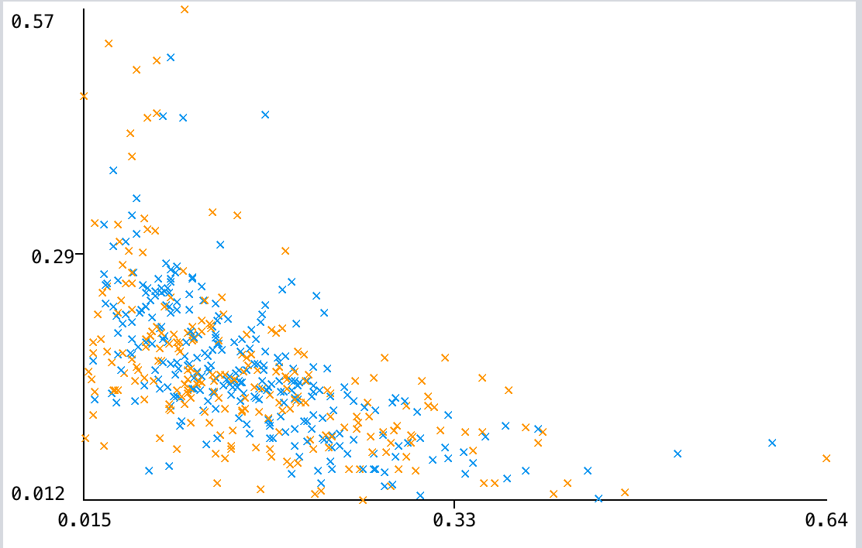

**Conclusion**

Data Analysis and Statistics are powerful tools for interpreting data and help us to make better decisions bases in numbers and not in intuition. Weka resulted to be an excellent to for making these tasks due to all the tools that it contains.